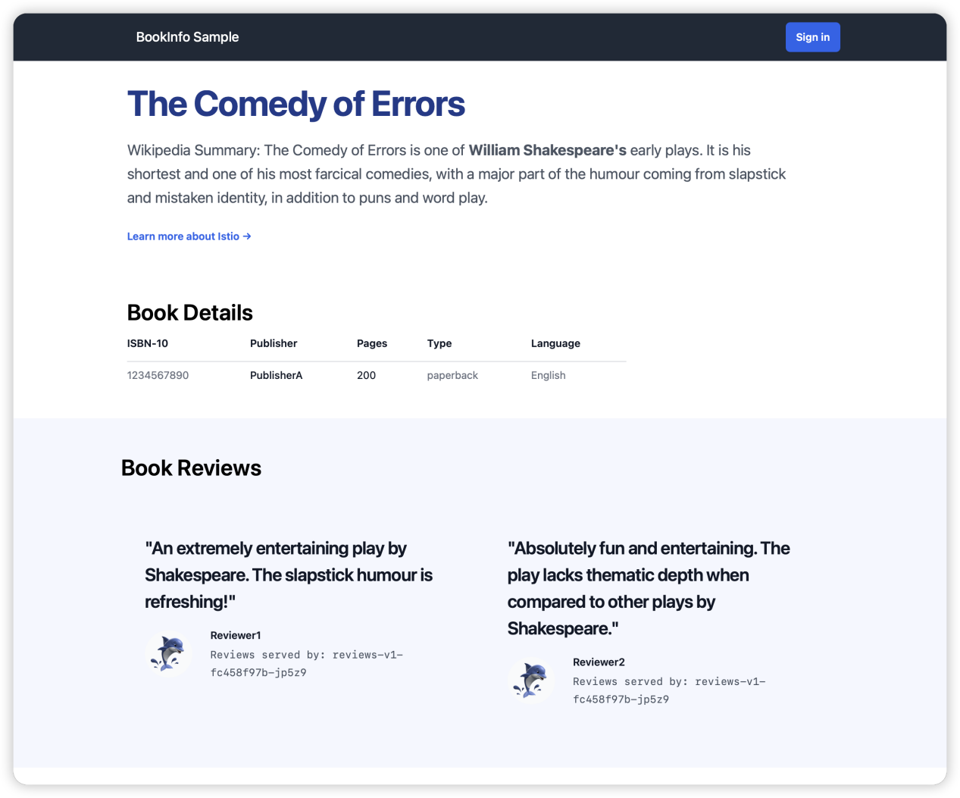
Productpage v1 (No Stars Shown)
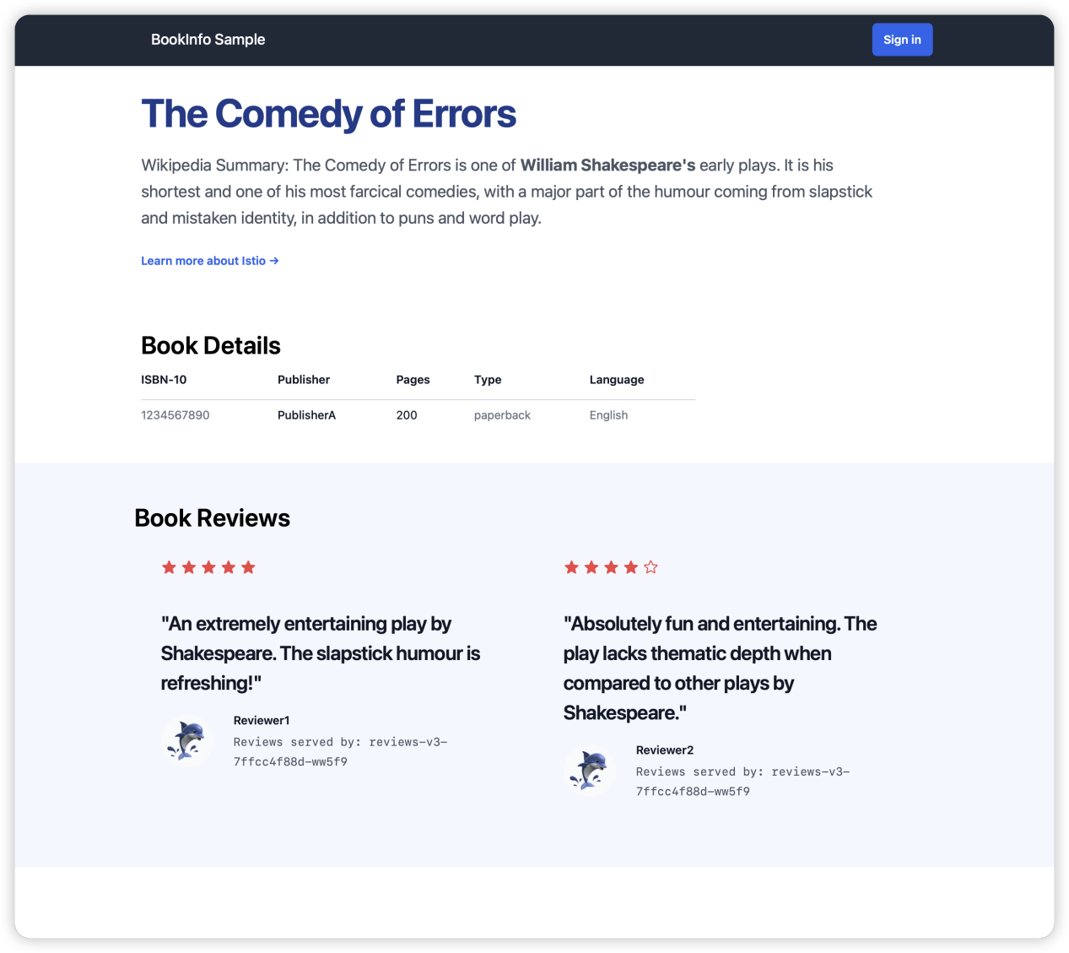Mixed Traffic (Red Stars Shown Occasionally)

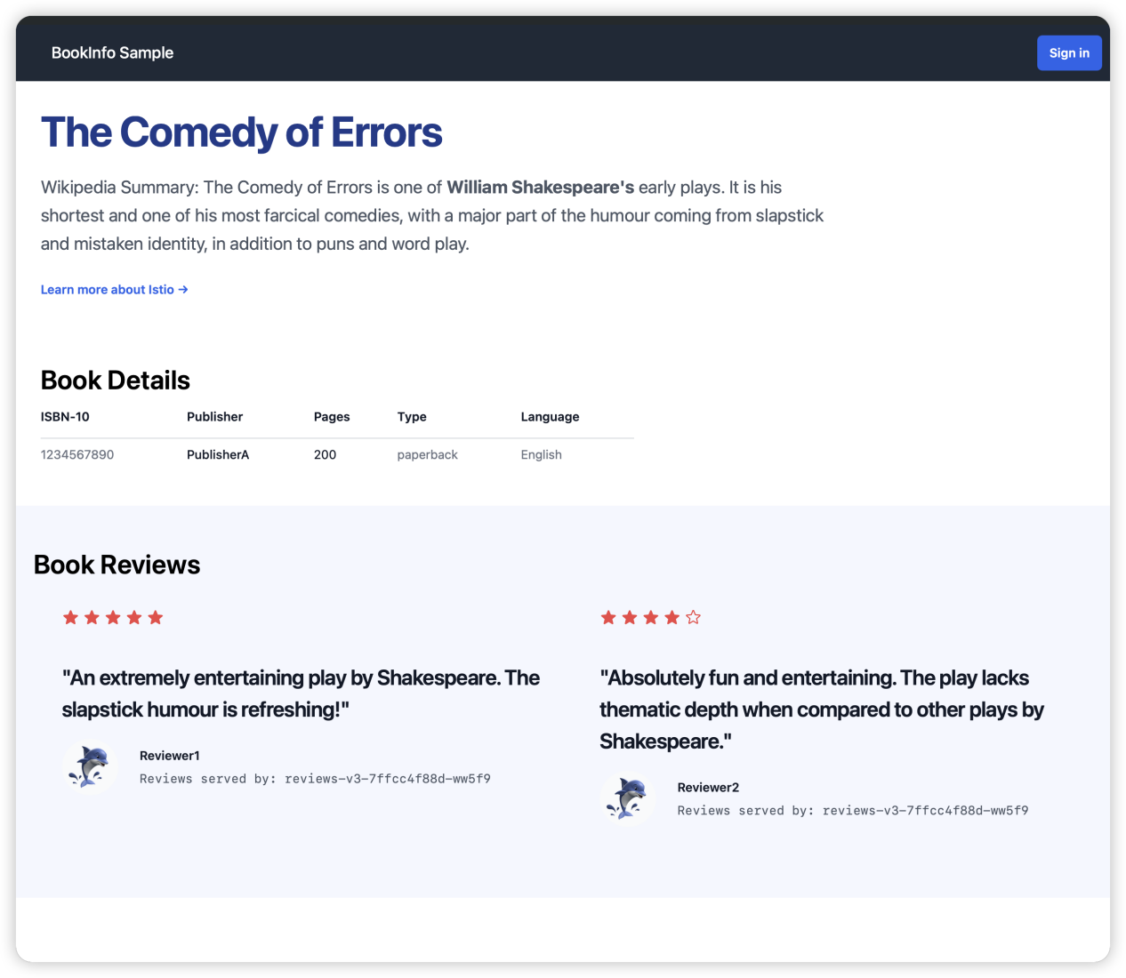
Productpage v3 (All Stars Shown)

